(540) 387-7169  (703) 404-9777  Mara@MarasHeavenlyHands.com www.MarasHeavenlyHands.com  Mara Castro, Owner/Head Trainer | Service Date/Time: Cleaner(s): Client Inspection Completed:  Get REWARDS for Referrals & Social Media Ratings!

COMMON AREAS * as needed, determined by tech |  | KITCHEN
MAINTENANCE CLEAN | - Cobwebs *Remove  - Fans / Shutters / Doors *Light Dust  - Blinds & Window Ledges *Light Dust  - Entrance Doors *Clean  - Mirrors Clean & Buff  - Upholstered Furniture Brush/Light Vac/Wipe  - Furniture & Shelves Dust  - Lamps, Lampshades, Lights Dust  - Door Handles & Wall Switches Sanitize  - Baseboards / Edging *Light Dust  - Carpets / Area Rugs / Closets Vac  - Hard Floors Sweep & Mop  - Personal Items, Blankets, Pillows Tidy  - Garbage Empty & Replace Bag |  | MAINTENANCE CLEAN | - Cobwebs *Remove  - Fans / Shutters / Doors *Light Dust  - Blinds & Window Ledges *Light Dust  - Cabinet Doors Light Dust  - Appliance Exteriors (Large & Small) Wipe  - Refrig/Freezer Interior Edges Wipe  - Microwave Interior & Exterior Wipe  - Stove, Drip Pans, Exhaust Hood Wipe  - Sink Clean & Sanitize  - Counters & Tabletops Clean & Sanitize  - Dishwasher *Fill & Run/Hand Wash  - Door Handles & Wall Switches Sanitize  - Baseboards / Edging *Light Dust  - Area Rugs Shake Out/Vac  - Hard Floors Sweep & Mop  - Garbage Empty & Replace Bag
DEEP CLEAN | - Upholstered Furniture Vac/Wipe  - Furniture & Shelves Wash/Polish  - AC/Heater Vent Fins Dust/Vac  - AC/Heater Filter (client provides) Replace  - Baseboards Vac/Wash |  | DEEP CLEAN | - Exhaust Hood + Fan Filter(s) Wash  - Stove Top Grates + Drip Pans Wash  - Cabinet Doors Dust/Wash  - Cabinet / Drawer Interiors Vac/Wipe  - Baseboards Vac/Wash
BEDROOMS |  | BATHROOMS
MAINTENANCE CLEAN | - Cobwebs *Remove  - Fans / Shutters / Doors *Light Dust  - Blinds & Window Ledges *Light Dust  - Mirrors Clean & Buff  - Upholstered Furniture Brush/Light Vac/Wipe  - Furniture & Shelves Dust  - Lamps, Lampshades, Lights Dust  - Door Handles & Wall Switches Sanitize  - Baseboards / Edging *Light Dust  - Carpets / Area Rugs / Closets Vac  - Hard Floors Sweep & Mop  - Personal Items, Blankets, Pillows Tidy  - Bed Tidy  - Garbage Empty & Replace Bag |  | MAINTENANCE CLEAN | - Cobwebs *Remove  - Fans / Shutters / Doors *Light Dust  - Blinds & Window Ledges *Light Dust  - Shower/Tub/Glass Doors Clean & Sanitize  - Toilet Clean & Sanitize  - Sink + Counters Clean & Sanitize  - Mirrors Clean & Buff  - Product Containers Wipe  - Towel & TP Holders Wipe  - Cabinet Doors Light Dust  - Door Handles & Wall Switches Sanitize  - Baseboards / Edging *Light Dust  - Area Rugs Shake Out/Vac  - Hard Floors Sweep & Mop  - Garbage Empty & Replace Bag
DEEP CLEAN | - Upholstered Furniture Vac/Wipe  - Furniture & Shelves Wash/Polish  - Baseboards Vac/Wash |  | DEEP CLEAN | - Cabinet Doors Dust/Wash  - Cabinet / Drawer Interiors Vac/Wipe  - Baseboards Vac/Wash

ADD-ON’S
- $35 Clean Refrigerator/Freezer Interior*
- $35 Clean Oven Interior*
- $10 Change Bedding (sheets, cases) - per bed
- $15 Laundry - per load ($15 minimum)
- $10 Wash Interior Window Glass
+ Track/Trim Detailing - per room*
- $20 Wash Blinds/Shutters - per avg. size window*
- $8 Wash Doors + Sill/Trim Detailing (both sides) - per door*
- $8 Wash Ceiling Fans - per fan
- $25 Detail All Kitchen Furniture (chairs, table, buffet, etc.)
- $20 Small Patio Cleaning (sweep, dust furniture, remove cobwebs)*
- $30 Large Patio Cleaning (sweep, dust furniture, remove cobwebs)*
Discounts available on some Add-On’s for Move-In / Move-Out Cleanings (see * above)
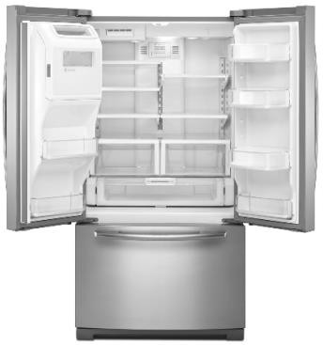
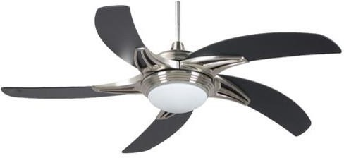
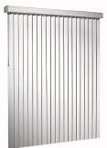
NOTES

Get $25 for each new client you refer to us!
On a prepaid Visa after new client completes their first cleaning. No Limit! ☺

Review us online and get entered into the
monthly Java Gift Card Drawing! One entry per online review ☺

YELP: https://www.yelp.com (please search “EcoTouch” in Scottsdale) GOOGLE: http://plus.google.com/118242670211671470680 FACEBOOK: https://www.facebook.com/ecotouchhome

